Vehicle handover and return form  From Sayarti+ — sayartiplus.com | Form no.: ________
 | Company logo

A. Company and employee |  |  | B. Vehicle
Company name |  |  | Make and model
Department or branch |  |  | Year
Employee receiving the car |  |  | Plate number
Employee no. (internal) |  |  | Colour
Job title |  |  | VIN (optional)
Mobile |  |  | Registration expiry
Driving licence expiry date |  |  | Insurance expiry
This form does not ask for national ID or Iqama numbers.

C. Condition at handover

Date and time |  | Place
Odometer (km) |  | Next service due (km or date)
Fuel level | □ Empty □ ¼ □ ½ □ ¾ □ Full | Cleanliness | □ Clean □ OK □ Needs a wash

D. Items and documents

Item | Present | Missing | Notes |  | Item | Present | Missing | Notes
Spare tyre | □ | □ |  |  | Registration card copy | □ | □
Jack and wheel spanner | □ | □ |  |  | Insurance policy copy | □ | □
Warning triangle | □ | □ |  |  | Number of keys: ___ | □ | □
First-aid kit | □ | □ |  |  | Remote or key card | □ | □
Fire extinguisher | □ | □ |  |  | Other: ___ | □ | □

E. Visible damage

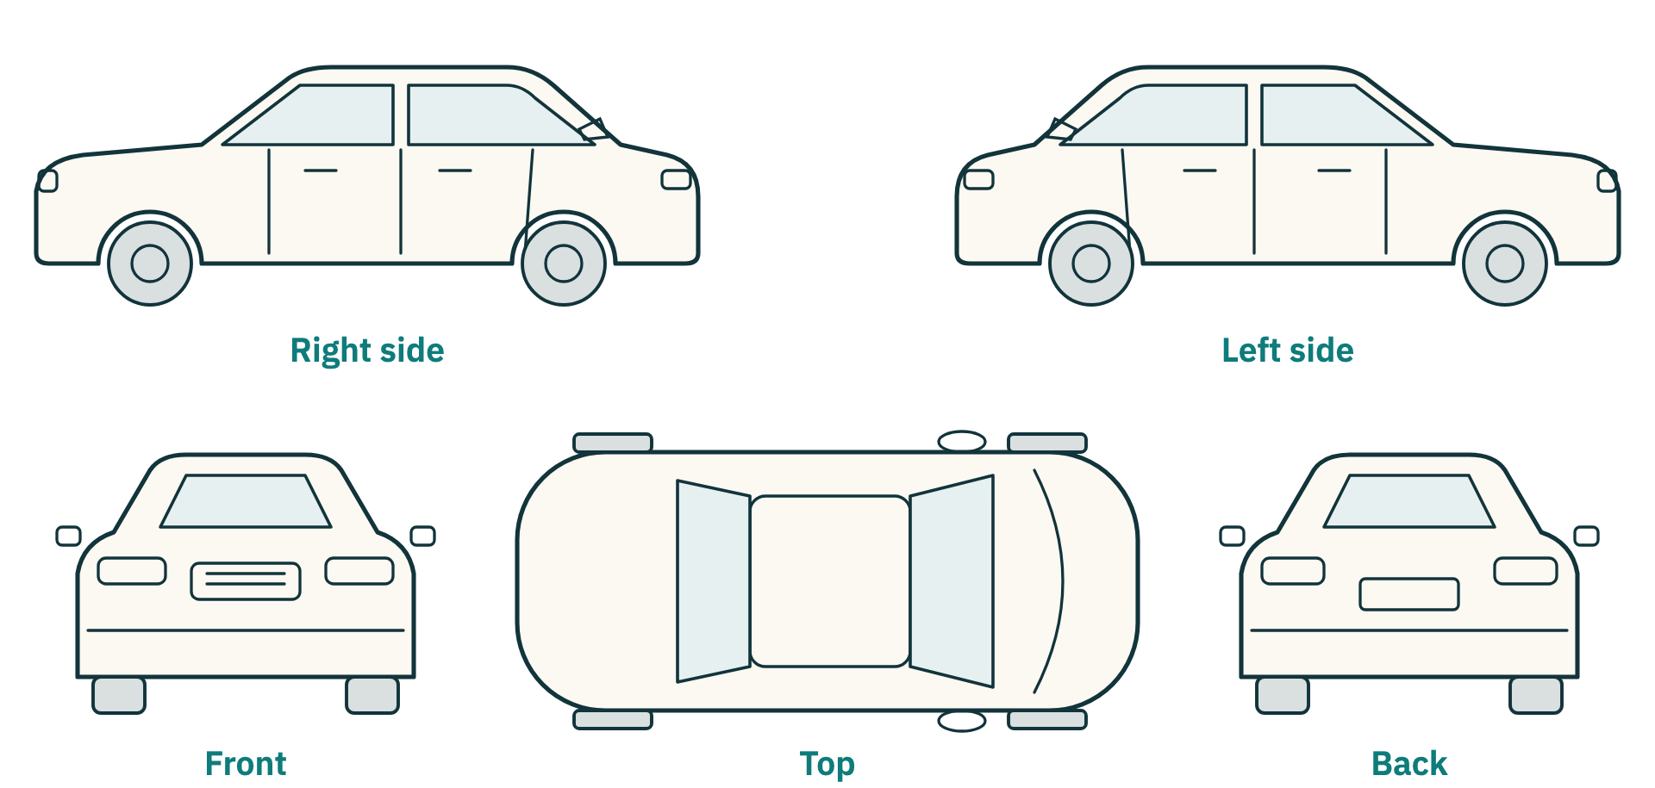  Mark on the drawing: S = scratch · D = dent · B = broken | Damage notes:  ______________________________________  ______________________________________  ______________________________________  ______________________________________  Photos taken of all four sides:  □ Yes □ No  Where are the photos kept?  ______________________________________

F. Acknowledgement and signatures

I confirm that I received the vehicle described above in the condition recorded, and I will look after it, use it for work in line with company instructions, return it on request in the same condition apart from normal wear, and report any accident, fine or fault to the company straight away.

Received by (employee) |  | Handed over by (for the company)
Name: ____________________ Date: ____________ |  | Name: ____________________ Date: ____________
Signature: __________________________________ |  | Signature: __________________________________

Vehicle handover and return form  Side 2: Return | Form no.: ________
Vehicle handover and return form  Side 2: Return | Plate number: ________

G. Return

Return date and time
Odometer at return
Km driven (return − handover)
Fuel level at return | □ Empty □ ¼ □ ½ □ ¾ □ Full
All items back? | □ Yes □ No Missing: ____________________
New damage? | □ Yes □ No Describe: ____________________
Fines during the period? | □ Yes □ No □ To check later

New damage at return (if any)

Mark on the drawing: S = scratch · D = dent · B = broken
Return notes:
______________________________________________________________________________________________________________
______________________________________________________________________________________________________________
______________________________________________________________________________________________________________

Received for the company |  | Employee
Name: ____________________ Date: ____________ |  | Name: ____________________ Date: ____________
Signature: __________________________________ |  | Signature: __________________________________
A guidance template from Sayarti+ for organising work inside your company. It is not an official document or legal advice. Check your country's labour rules or a legal adviser if you need binding wording.

